South Dakota Humanities Council
Grant Application Template

(**This is not the actual application; use this template for planning purposes only**)

Because you will be unable to save your progress as you are completing the online application form, you can use this application template as a planning tool. We recommend that you plan out your application in this form to prevent you from losing your work in case the online service times out.

This Word document provides the data fields and presents the general format of our online SDHC grant application. Please use this template only to organize information before completing and submitting the online application. This document cannot be submitted as an application. The official application is available on our website, sdhumanities.org.

Thank you for your interest in a South Dakota Humanities Council grant. We review grant requests of $2,000 or less on a rolling basis throughout the year, as funding allows; for grant requests of more than $2,000, our deadlines are Oct. 15 (for programs taking place after December 1) and Feb. 28 (for programs taking place after May 1) each year. Please review the current Grant Guidelines and General Grant Requirements on our website prior to completing your application.

The following documents will be needed to support your application. Please prepare them in advance as you will be unable to save your progress as you are completing the online application form:
- A UEI number (Unique Entity ID) and active registration in the System for Award Management (SAM).
- Scholar CV – each scholar CV must be limited to 2-pages maximum. If the project has more than one scholar, all of the two-page CVs may be put into one document to upload.
- A completed, budget request form
- NICRA (if applicable)

You can request that an SDHC staff member review your draft proposal, but you must submit that request two weeks before the application deadline. If you have questions about the application process, please contact the South Dakota Humanities Council at 605-688-6113 or melinda@sdhumanities.org.

Grant Application Template

All fields are required unless otherwise indicated

Page 1: Sponsoring Organization
Type of Grant:
  - Discussion
  - Media
  - Research
  - $2,000 or less
Sponsoring Organization:
Name
Address, city, state, zip code
Email
Phone number
URL (optional)
9-Digit Federal Taxpayer ID Number (also referred to as your organization's "EIN"):
12-Character UEI Number (also referred to as Unique Entity ID):
Documentation of tax-exempt status (if available)
[File upload]

Page 2: Program Information
Project title:
Project start date: (when you expect to start planning your project):
Project end date: (when you expect to complete your project):
Public Event start date: (the date of your public event):
Public Event end date: (if your event spans more than one day):
Public Event start time: (the start time of your public event):
Public Event end time: (the end time of your public event):

Brief description of project:
[max. 100 words]
Event venue name:
Event venue location:
Address, city, state, zip code
Venue county:
Please select the program format:

- Conference / Symposium, etc.
- Discussion Program
- Exhibit
- Fellowship for Higher Ed. Faculty
- Festival
- K-12 Teacher Project
- Library Project
- Literacy Project
- Local History Project
- Media Grant - Film
- Media Grant - Radio
- Media Grant - Technology
- Media Grant – TV
- Museum Project
- Preservation Project
- Publication
- Student Project

Has your organization applied for or received a grant from the SDHC? If so, please list the projects and grant numbers in the last 10 years. [max. 250 words]

Page 3: Program Narrative
Please describe the sponsoring organization.
[max. 500 words]
What is the proposed project?
[max. 500 words]
Please explain how your project advances the mission of the South Dakota Humanities Council and promotes the Humanities in American public life.
[max. 500 words]
Who is your intended audience?
[max. 250 words]
Estimated attendance:

Page 4: Scholars & Support
Who are the humanities scholars involved and what are their credentials? How will they contribute to the proposed activities? If no scholar CV is uploaded your grant application will be considered incomplete. Note: Grant scholars do not need to be on our Speakers Bureau list. [max. 500 words]
[File upload: Scholar CV; two-page maximum] (at least one scholar CV is required)
[File upload: Additional scholar CV; two-page maximum] (optional)
(Each scholar CV is limited to two pages. If you wish to include multiple CVs, you may put the individual CVs into one document and upload that single document.)

Will other organizations be involved in this project? If so, please describe each organization and explain its involvement. (You may attach support letters or other documentation below.)
[max. 500 words]
[File upload: Letter of support or endorsement] (optional)
[File upload: Additional letter of support or endorsement] (optional)
What specific goals relating to humanities programming do you propose to achieve?
[max. 500 words]
[File upload: Additional supporting document] (optional)

Page 5: Program Budget
Download and complete the Excel Budget Form found on the SDHC grants webpage. In a separate narrative document, provide a complete rationale for each SDHC budget expense, making your descriptions as detailed as possible. Upload both documents here.
[File upload: completed Excel budget form]
[File upload: Budget rationale]
If your budget form includes a federally negotiated indirect cost rate for Project Administration, you must upload a copy of the applicant organization’s current NICRA for review here.
[File upload: NICRA]
Grant amount request:
Summary of proposed budget
SDHC contribution:
Cash Contributions (non-SDHC):
In-kind Contributions (donated):
Total project budget:

Page 6: Contacts & Signatures
Project Director: (The Project Director is the person who manages the overall project, serves as the contact person with SDHC and submits the final documents – cannot be the same as the Fiscal Agent)
Name
Email (indicate work or personal)
Phone number (indicate work, home, or mobile)
Address, city, state, zip code (indicate work or home)
Fiscal Agent: (The Fiscal Agent must be affiliated with the sponsoring organization and cannot be the same person as the Project Director)
Name
Email
Phone number
Address, city, state, zip code
Authorizing Official: (The Authorizing Official is the person with authority to sign the application on behalf of the organization)
Name
Email
Phone number
Address, city, state, zip code
Electronic signatures. By typing below, you agree that your project complies with the SDHC Grant Guidelines and that your application is accurate to the best of your knowledge.
Signature of Project Director
Signature of Fiscal Agent
Signature of Authorizing Official

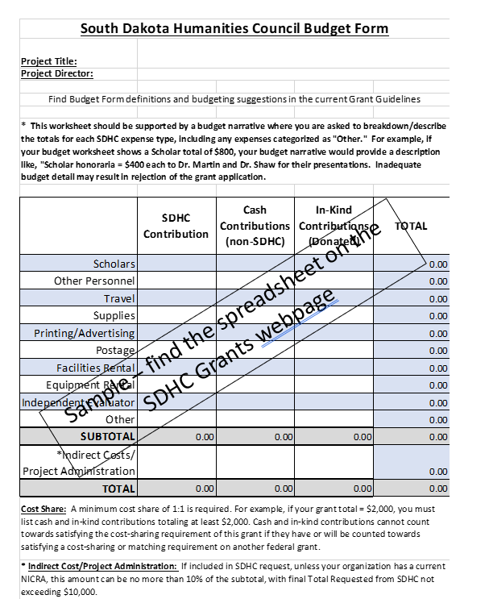

South Dakota Humanities Council Budget Form
Definitions and Budgeting Suggestions

The South Dakota Humanities Council will cover up to one-half the total cost of your project. Cost share shows how federal funds are being matched by local community support and are an important requirement in NEH grantmaking. Applicants’ total cost share, which includes cash contributions and in-kind donations, must equal or exceed the amount requested from SDHC. For example, if you request $2,000 from SDHC, the other two columns must equal $2,000 or more. Do not include any cash or in-kind costs that have been, or will be, counted as match on any other award of federal funds.

All expenses must be solely for the purposes of the grant, occur during the grant period, and in accordance with the agreed guidelines and provisions of the award.

* Indirect Costs. SDHC will honor valid federally negotiated indirect cost agreements (NICRA) for Project Administration if the applicant organization can provide a copy of the NICRA for review along with the application. This NICRA must be current, not expired, and the effective date for the rate must be applicable to the period of the grant. NEH activities most regularly fall within “Other Sponsored Activities” under the “Applicable To” column on the NICRA. Applicant organizations may not apply a research rate to their indirect costs. If an event is scheduled to occur off campus, the applicant organization is advised to read the definition of “off campus” that is provided in their individual rate agreement, since this definition varies and is sometimes very specific.

If the applicant organization chooses to not use the full indirect cost rate, as an SDHC expense, or to waive the indirect cost rate, they may include this as a cash contribution. The grantee in turn stipulates that the amount provided as a cash contribution is in keeping with its normal procedures for computing such costs.

If the applicant organization does not have a NICRA, they may elect to include no more than 10% of the SDHC subtotal for Project Administration.

Cash contribution refers to actual money spent for the project, either by the sponsoring organization, other organizations or individuals. This may include salary, travel, purchase and use of office supplies, facilities/equipment rental—anything being paid for but not being paid for by SDHC.

In-kind contributions refer to the dollar value of donated services, such as donated scholar time and/or travel, volunteer labor, donated meeting space, equipment, or supplies - anything that is an integral part of your project and that is contributed or discounted for the project. The NEH is interested in knowing the resources that were used to create your project that were not paid yet were necessary for its successful completion, and we appreciate your care in thoroughly reporting these figures. While you will be able to best determine the value of these elements, as a beginning point, SDHC suggests in-kind volunteer time to be reported as $25/hour, while in-kind volunteer scholar time can be reported as $60/hour or $480/day. Donated meeting space can be reported as an in-kind contribution of $400/day.

When calculating travel expenses, use the current federal mileage rates shown at the following website: https://www.irs.gov/tax-professionals/standard-mileage-rates. SDHC reimburses mileage for in-state travel only. Airline tickets and car rental from the airport are allowed. Food expenses typically aren’t covered by SDHC, but exceptions can be made for per-diem allowances; per-diem will follow current federal reimbursement rates – Breakfast ($13) Lunch ($15) Dinner ($26).

